EXECUTIVE SUMMARY

MyCarDoesWhat.org is the name of the national driver education safety campaign developed by the National Safety Council (NSC) with funds awarded through the Toyota Unintended Acceleration Economic Loss Settlement to the University of Iowa. The focus of the campaign is on active safety features (also known as advanced driver assistance systems). Active safety features are vehicle technologies designed to help drivers avoid crashes.
Under the terms of the grant, the university would have overall responsibility for the project implementation, but specifically would also be responsible for the national consumer survey on “driver attitudes, behaviors and levels of understanding concerning defensive driving techniques and the proper use of new automotive technology” (Automobile Safety and Education Program, 2016). The university partnered with NSC and a third partner to co-develop and implement the National Driver Safety Education Campaign (which would be later called MyCarDoesWhat).
The Council would be tasked with developing educational materials for the campaign, including short videos, graphics, public service announcements and more. NSC would also be responsible for marketing the campaign, through its own means or with the assistance of a public relations firm or advertising agency. The third party brought into the project would be responsible for the development of an interactive educational game, the campaign’s website, and other responsibilities.
Subsequently, the tasks for which the third partner was responsible were given to NSC. Some of the resources behind the website and interactive game were lost in this process, including significant budget allocation and the time spent developing those materials.
The Council hired a staff to complete the work of developing the educational media in-house. Materials for the campaign began to be developed in 2014 before launching publicly by late spring 2015. This was a “soft launch” as the campaign’s materials had not yet been nationally advertised. The soft launch served to test the usability of the materials in a real-world environment and get feedback on the content and presentation.
On Oct. 7, 2015 at a Washington, D.C. press conference, the campaign was officially launched. The press conference featured the U.S. Secretary of Transportation, administrator of the National Highway Traffic Safety Administration and leaders from the University of Iowa and the National Safety Council. The earned media generated by this event contributed to an estimated more than billion campaign impressions during the month.
During the soft launch phase, key campaign elements including a website and social media campaigns on Twitter and Facebook launched to start building momentum for the actual launch. The weeks after the campaign launch also saw the release of a nationwide traditional media campaign, including spots on radio and TV as well as advertisements in newspapers, on websites, and in smartphone apps.
Subsequently, the MyCarDoesWhat campaign partnered with major industry and government associations and agencies to further the reach of the campaign’s materials.

Topline Results

Paid Media
Paid media contributed 700,884,696 media impressions to the campaign’s impression total. Additionally, placements of the public service announcement added 11,907,966 impressions to the campaign’s total impressions. Paid social media advertisement contributed 123,283,450 impressions. Earned (organic) social media impressions are described in later parts of this document.

Earned Media
Impressions gained from unpaid media impressions accounted for the majority of the campaign’s overall impressions – 4,975,359,404, or more than 85 percent of all impressions.

Owned Media
Overall, the campaign’s owned media – including the website, organic social media content, games and app – contributed 977,844 impressions to the campaign’s overall impressions goal.
MYCARDOESWHAT EDUCATION AND

MEDIA PROGRAM EVALUATION

EXECUTIVE SUMMARY 1
Topline Results 2
Paid Media 2
Earned Media 2
Owned Media 2
CHAPTER ONE: BACKGROUND AND DEVELOPMENT 6
Campaign Goals 6
Impressions Goal 6
Education Outcomes Goals 7
Creating The Campaign 9
Development of the Educational Materials 9
Visual Presentation Focus 9
Videos and Animations 10
Graphics 11
Deeper Learning 12
Development of the Mass Media Campaign 13
Campaign Launch and Implementation 14
Overview of Impressions Results 15
CHAPTER TWO: PAID MEDIA 17
Media Strategies in 2015 17
Out of Home 18
Radio 19
TV and Print PSA 19
Online Paid Media 19
Other Tactics 21
Paid Social Media 21
Audience Segmentation 22
Topline Results 24
CHAPTER THREE: EARNED MEDIA 25
CHAPTER FOUR: OWNED MEDIA (PRIMARY EDUCATION CHANNEL) 27
Website (MyCarDoesWhat.org) 27
Mid-Campaign and Iterative Evaluations 28
Website Topline Results 29
Owned (Organic) Social Media 30
Formative Evaluation 32
Campaign Blog and Underused Long-Form Content 32
Videos 33
Games and App 36
Game and App Topline Results 36
Resulting Demographics of Campaign’s Owned Media Audiences 37
Age Group 37
Biological Sex (Gender) 41
Device Use 44
CHAPTER FIVE: OTHER EVALUATION TOOLS AND CONCLUSION 46
Surveys 46
National Survey of Consumer Driver Safety 46
Advanced Vehicle Technology Consumer Survey 46
Website Efficacy Study 46
Partnerships, Collaboration and Sharing 46
Social Media Listening 48
Additional Learnings and Next Steps 49
REFERENCES 51
Appendix A: Evaluation Results by Campaign Educational Goal 52
Appendix B: Examples of Earned Media About MyCarDoesWhat Campaign 56
Appendix C: Speaking Engagements and Other Opportunities Used to Promote MyCarDoesWhat 58

CHAPTER ONE: BACKGROUND AND DEVELOPMENT

MyCarDoesWhat.org is the name of the national driver education safety campaign developed by the National Safety Council (NSC) with funds awarded through the Toyota Unintended Acceleration Economic Loss Settlement to the University of Iowa. The focus of the campaign is on active safety features (also known as advanced driver assistance systems). Active safety features are vehicle technologies designed to help drivers avoid crashes.

Campaign Goals
There are two main sets of goals for MyCarDoesWhat. The first set encompasses the media impressions goal determined by the Toyota Economic Loss Settlement’s National Automobile Safety Education Campaign (ToyotaSettlement.com, 2014). The second set of goals includes the education outcome goals determined by the campaign’s evaluation staff and leaders.
Additionally, the campaign embraced best practices in public health intervention implementation through a mid-campaign evaluation. This helped ensure the campaign’s goals were on-target as well as keeping up with best practices in media and marketing. The campaign also tracked key campaign engagement metrics on a regular basis.

Impressions Goal
For the purposes of this evaluation, an impression refers to any time in which a U.S. citizen was exposed to any element of the National Driver Safety Education campaign, later known as “MyCarDoesWhat.”
The Toyota Economic Loss Settlement’s Automobile Safety and Education Program advised the following impression goals for the eventual National Drivers Safety Education campaign:
“The goal for reach/frequency for the program will be 90/12 (i.e., 90 [percent] of adults in key target markets would see the company’s message 12 times over the length of the campaign). This is based on an audience target of age 18 or older.” (Automobile Safety and Education Program, p.2, 2014)

Based on the scope of the assignment, including funding resources and time, the University of Iowa interpreted the media impressions goal into a gross impressions number determined as follows. At the time of its writing, the document “National Driver Safety Education Campaign” (April 2013) notes that there were 314 million people in the United States, with 75 percent over the age of 18 years old. As the settlement’s target audience states that the campaign must reach 90 percent of driving-age adults, this leaves a target population size of 212.4 million. Exposing each member of this target audience to campaign materials 12 times would require 2.5 billion exposures – which constitutes the MyCarDoesWhat campaign’s ultimate impressions goal.

Education Outcomes Goals
The second set of goals was determined by the campaign’s evaluation and strategy teams. Through a series of meetings, the teams developed a list of education outcomes they hope the campaign to achieve (Appendix A). This was in addition to identifying specific actions and behaviors linked to the outcomes (Table 1), indicators the outcomes were being reached (Appendix B) and a program plan to achieve these outcomes (Appendix C).

Education Outcomes
The broad education outcomes identified were the following.
- Increase U.S. drivers’ knowledge of active safety features in their vehicles with a campaign focused on how to interact with them appropriately.
- Reduce crashes, injuries and fatalities with this knowledge and increased use of defensive driving skills.
- Encourage drivers to be more active and engaged.

Outcomes Linked with Specific Actions or Behaviors
The following outcomes in Table 1.1 would indicate that the campaign is reaching its goals. These outcomes would later make up the basis of much of the campaign’s evaluation, in addition to the specific inputs, outputs, distribution channels and tracking methods also defined throughout the report.

Table 1.1
Outcomes Linked with Actions and Behaviors
Goal # | Outcome | Specific action/behaviors
No. 1 (Initial) | Seek further information | Increase the number of:  - people visiting MyCarDoesWhat.org  - engaged users visiting MyCarDoesWhat.org  - viewing campaign videos  - reporting seeking of information behaviors on surveys
No.2 | Have more knowledge | Increase the number of people:  - correctly answered knowledge questions  - returning visitors to MyCarDoesWhat.org  - reporting gain in knowledge on surveys
No. 3 | Support and educate others – Audience | Increase the number of people:  - reporting having shared or intending to share the MyCarDoesWhat website, or on social media with friends/family;  - engaging in positive social media conversations (and decreasing in negative conversations)
No. 4 | Support and educate others - Partnerships | Increase the number of:  - partnerships developed to promote and advance vehicle safety technology  - policies implemented with partnerships  - testimony, presentations, meetings, conferences
No. 5 | Drive better and safer | Increase the number of people:  - reporting feeling like a safer driver on surveys

The progress toward achieving these goals are on track with the intentions of the campaign. The goals will continue to serve the campaign, at least for the foreseeable future, as NSC has decided to internally fund and continue the work of the campaign past December, 2016. For the results of the evaluation based on goal, see Appendix A.

Logic Model and Information Attainment and Adoption Model
To guide the implementation of the MyCarDoesWhat campaign, the Information Attainment and Adoption Model (Chavez, 2015) was utilized (Figure 1.1). Health promotion campaigns using theories or models consistently produce stronger behavioral changes and are more effective interventions. The proposed Information Attainment and Adoption Model (IAAM) integrates components of the Theory of Motivated Information Management and the Precaution Adoption Process Model.

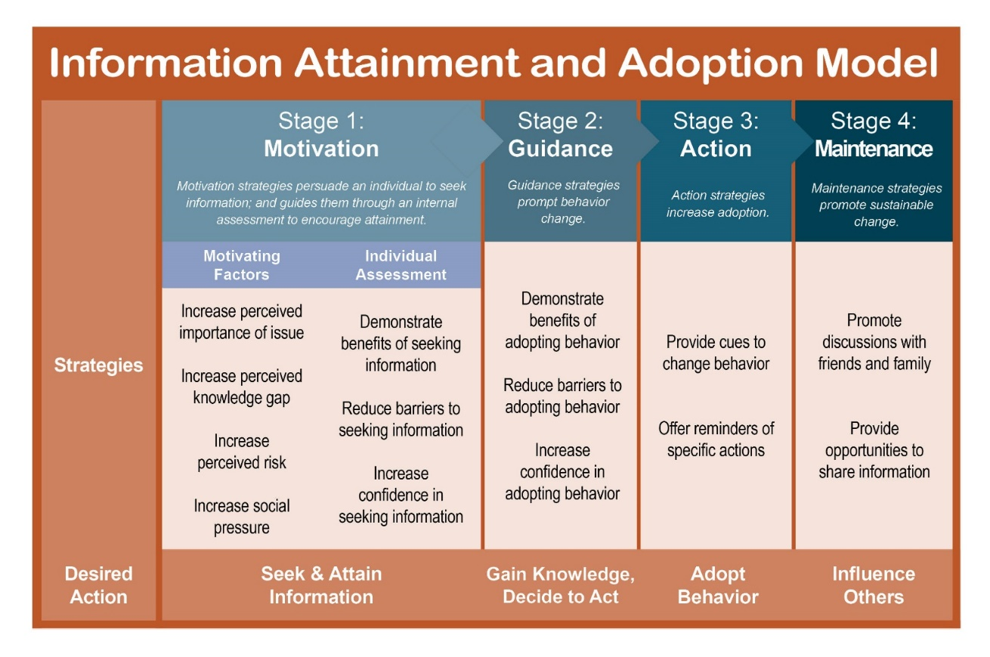
Figure 1.1. Information Attainment and Adoption Model

The IAAM uses strategic constructs in a semi-staged design to move individuals from being unaware of an issue to seeking and attaining the information to maintaining the behavior. The model is based on four stages: motivation, guidance, action and maintenance. The model is intended to be flexible enough to be used for a variety of health promotion issues and with a variety of communication channels. The IAAM was used to support the development of effective content for the MyCarDoesWhat campaign.
The logic model was developed (Figure 1) by NSC and University of Iowa staff researchers.

Creating The Campaign

Development of the Educational Materials
Naming the campaign was the first order of business. The team wanted to find a name that was distinct, catchy and descriptive. The name eventually chosen fits those criteria.
Both the name of the campaign and the primary video presentation methods were focus-group tested to gather feedback and gauge acceptability. The campaign’s emphasis on videos, graphics, animations and other visualizations was incorporated to minimize reading and provide drivers the basic knowledge they need to use active safety features safely.
MyCarDoesWhat.org is the foundation of this driver education campaign. Its development was based on the belief that by increasing knowledge about these features, all drivers would be able to use them correctly and to be safer on the roads. Hence, one of the campaign’s taglines – “Know More, Drive Safer.” Yet, in the cluttered (and expensive) world of traditional and online media, it was clear that getting people to visit the website would require a strong call-to-action and a variety of awareness strategies that would, in themselves, increase driver knowledge and curiosity, hopefully leading them to visit the website.
MyCarDoesWhat.org provides the user the opportunity to learn about vehicle safety features with friendly, easy-to-use graphics (both static and animated); videos with an approachable host and his dog; and simple to understand text that is easy to read and digestible. The campaign website was designed as a robust “Wikipedia” to provide information to users on-demand.
As will be described in the “Owned Media” section of this document, the campaign’s directors and designers continually evaluated the effectiveness of the owned media at achieving its goals. Some efforts included a complete mid-campaign evaluation, monthly tracking of user feedback about the website and evaluations of the campaign’s social media materials on U.S. social media users.

Visual Presentation Focus
Guiding the development of the educational materials were the goals to make them attractively presented, easy to understand and highly visual. It was clear to us the campaign’s directors that if the materials were not attractively package, they could not compete with all other offerings on the internet. The videos, graphics and animations had to be easy to understand. While the designers were aware that some segment of the driving public that accessed the materials might be interested in reading large volumes of text, the bulk of drivers would be interested in quick, easy to understand answers to their questions on how to operate these safety systems. Finally, the graphics and videos were designed to be easy to point to from other sites on the internet, or were easy to download and re-distribute.

Videos and Animations
Videos and animations (Table 1.2) were developed to be primary educational message delivery systems. The longest video type (explainer) was two-and-a-half minutes. It involved a friendly host and his faithful dog describing how drivers should properly interface with each safety system. A shorter video – the 30 second quick guide animation – distilled the basic information into a shorter, more digestible, more simplified segment. Finally, the Welcome video was created as an introduction video for visitors to the website, as well as a multipurpose video that could serve as an introduction to the campaign at meetings, during seminars, etc.

Table 1.2
Basic Video and Animation Styles and Examples
Name of Video | Campaign Nomenclature | Description | URL | Thumbnail
Rick & Scout Explain Back-Up Cameras & More | “Driver Interface Video” | A focus-tested video style featuring a live actor explaining an active safety feature | http://youtu.be/6ONwgBCwKsQ | 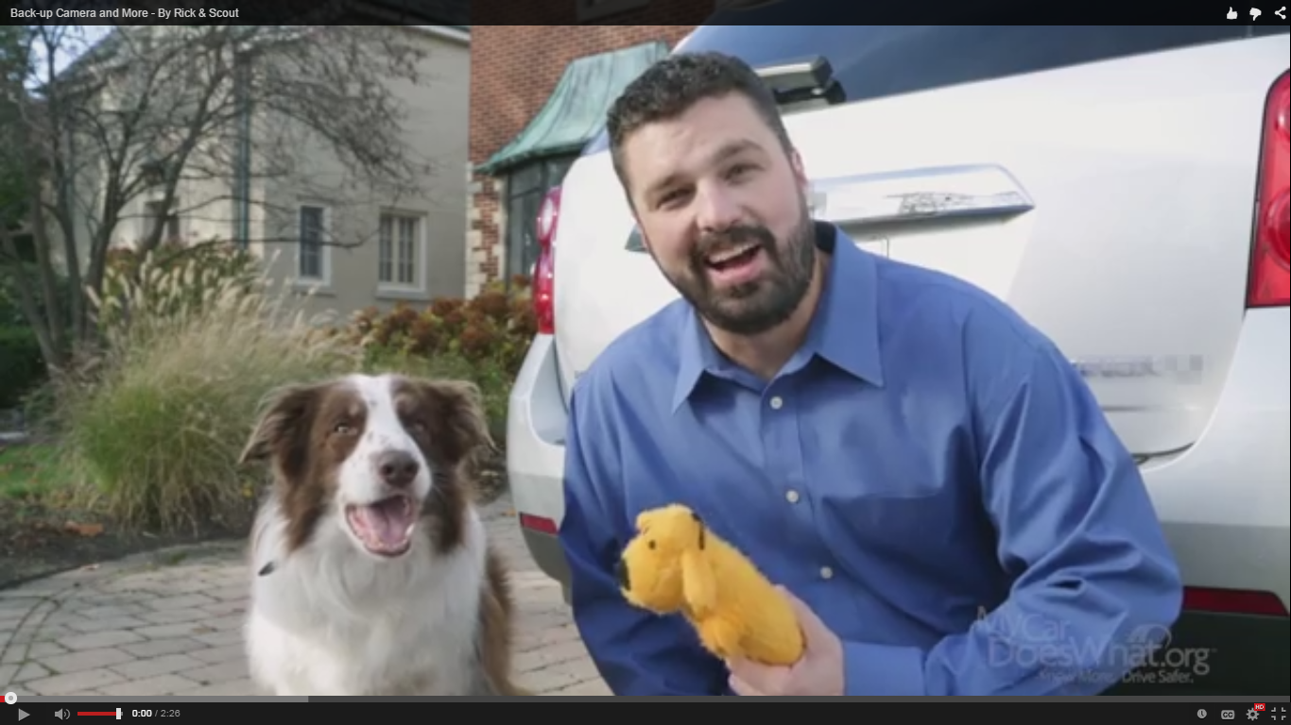
Back-Up Cameras & More – Quick Guide | “Quick Guide Animation” | 30 Second basic facts driven animation | https://www.youtube.com/watch?v=DO76iCibbjo | 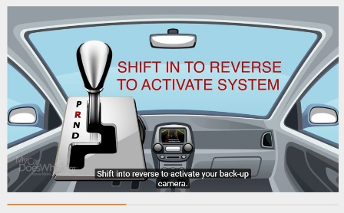
Campaign Welcome Video | “Welcome Video” | Short video in engaging style to highlight how understanding safety systems can help keep drivers safe. | https://www.youtube.com/watch?v=08esjtVHZBI | 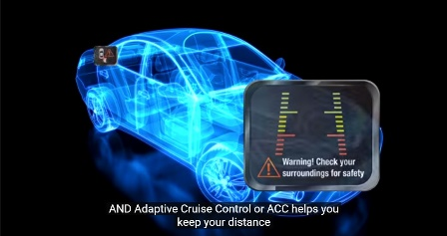

Graphics
The graphics of the campaign (Table 1.3) were designed to be easy to understand, to form a complete set of safety feature guides, to be downloadable, shareable, and even to be used as posters in various settings where there were high volumes of questions to be answered about safety features. They accompanied the videos, but were meant to be stand-alone educational pieces. One set – the quick guide, was essentially three panels that explained the features with as little text explanation as possible.

Table 1.3
Basic Video and Animation Styles with Examples
Name of Graphic | Campaign Nomenclature | Description | URL | Thumbnail
Tire Pressure Monitoring System: Helps You Prevent a Blow Out | “Infographic” | A graphical explanation of an active safety feature. Uses more information than a standard graphic explanation (a “Quick Guide”). | https://mycardoeswhat.org/wp-content/uploads/2015/05/MCDW-TPMS.pdf | 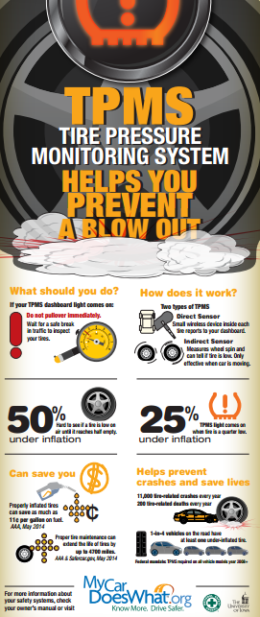
Driver Safety Feature Guide to Tire Pressure Monitoring Systems | “Quick Guide” | Three panel, easy to understand basic description of Tire Pressure Monitoring Systems – part of a comprehensive series of quick guides. | https://mycardoeswhat.org/wp-content/uploads/2015/05/MCDW-Quick-TPMS.pdf | 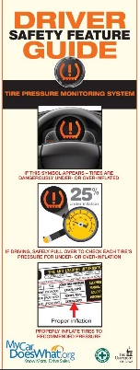
Fun categorization of Safety Features into a table much | Periodic Table | This chart is designed to give a visual, scientific, presentation of all ADAS safety features that could be used as a unique hallmark of the campaign | (not available online) | 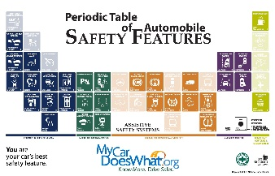

Deeper Learning
The University of Iowa’s Educational Psychology & Learning Sciences department in the College of Education produced a set of advanced learning tools to support the educational aspect of the campaign website. Collectively referred to as “Deeper Learning,” they included detailed explanations of the technologies behind three prominent active safety features. Each page also included quizzes for visitors to test their knowledge and easily downloadable versions of the pages. Last, the page for adaptive cruise control featured a fully interactive game demonstrating how this technology works, known as plAyCC (Figures 1.2 and 1.3).

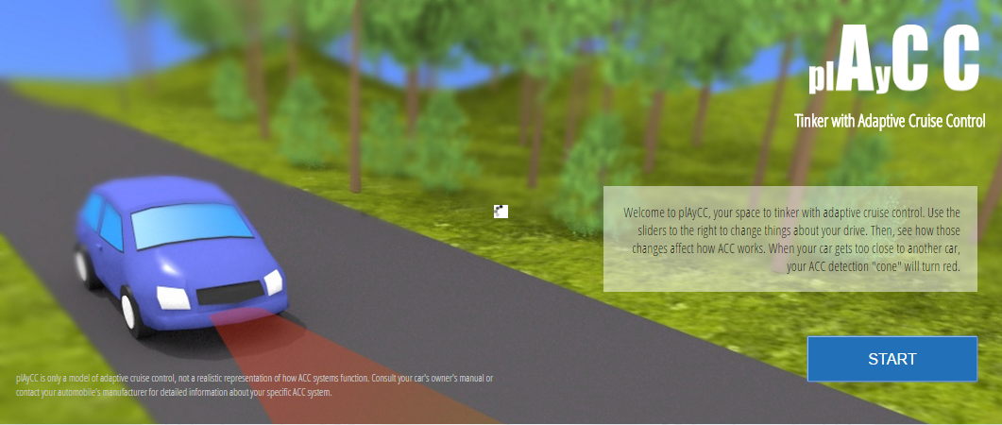
Figure 1.2. Interactive Explanation of Adaptive Cruise Control, Title Screen
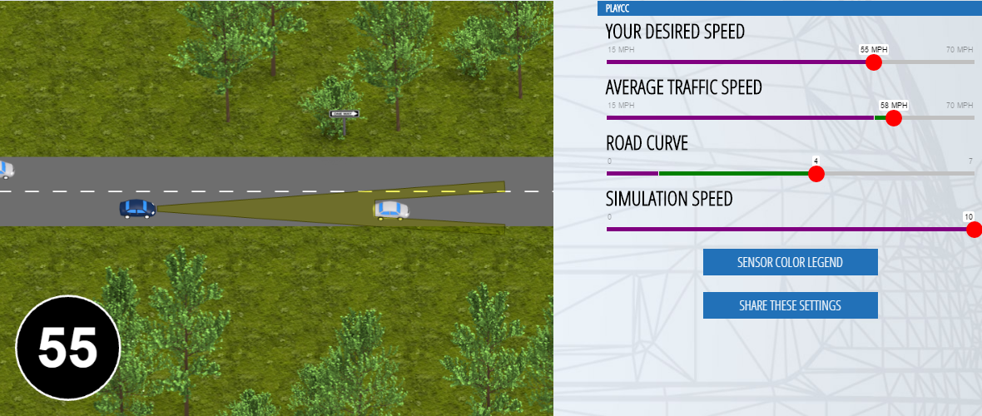
Figure 1.3. Interactive Explanation of Adaptive Cruise Control, Gameplay

Development of the Mass Media Campaign
A request for proposal was circulated to find a nationally recognized firm to help formulate the media plans for the eventual campaign to reach the required 2.5 billion impressions. Several agencies dropped out during the request-for-proposals phase, calling the goal unattainable given the budget. Eventually, a series of strong candidates emerged and the nationally recognized firm, Qorvis MSLGROUP, was hired. This Washington, D.C.-based public relations firm was chosen in part because of their excellent reputation and their position as part of a much larger network incorporating media buying and advertising capabilities.
Qorvis MSLGROUP’s work began in March 2015 and culminated in December, 2016. The assignment was to help the National Safety Council and the University of Iowa raise awareness of the new website and campaign to help encourage safer driving using vehicle safety features.
The University of Iowa steered, approved and counseled both the agency and NSC on the direction of the campaign and accompanying media outreach efforts.
The goals for the initial phase were to align with the logic model and satisfy the impressions requirements:

- Raise awareness of active safety features among U.S. drivers
- Drive visitors to MyCarDoesWhat.org to learn safe driving skills
- Influence drivers’ attitudes and behaviors toward vehicle safety technologies
- Secure 2.5 billion impressions

A multi-prong strategy was employed:

- Connect to human truths
  - People think they are better drivers than they are
  - Drivers don’t “get” new automotive technologies
- Capture drivers at key moments:
  - When they are buying a vehicle
  - In bad weather
  - When they are caring for their vehicle or planning a road trip
  - In traffic

As will be described in the “Paid Media” and “Earned Media” sections of this document, the media campaign tactics employed were continually evaluated by all partners of the campaign. Some of the results of this continual evaluation included new tactics employed to reach new audiences, distributing funds away from less efficient advertisers into more effective ones, expanding the scope of existing tactics and experimenting with new content styles to keep the campaign up-to-date with the latest trends in content and social media advertising.
Prior to the campaign launch, the National Safety Council (NSC) and University of Iowa invited a newly created advisory group of experts and “lay” panelists to provide their feedback. The expert advisory group was comprised of members from the Insurance Institute for Highway Safety, National Automobile Dealers Association, Alliance of Automobile Manufacturers, ADEPT Driver, Queensland University of Technology, Chrysler Group LLC/Michigan, Safety Center Incorporated and the Auto Maintenance and Repair Association. The advisory group reviewed the educational materials and providing suggestions about content, technologies and scope.

Campaign Launch and Implementation
The MyCarDoesWhat campaign was officially launched on Oct. 7, 2015 at a Washington, D.C. press conference (Figure 1.4). The launch featured the U.S. Secretary of Transportation, the administrator of the National Highway Traffic Safety Administration and leaders from the University of Iowa and the National Safety Council.

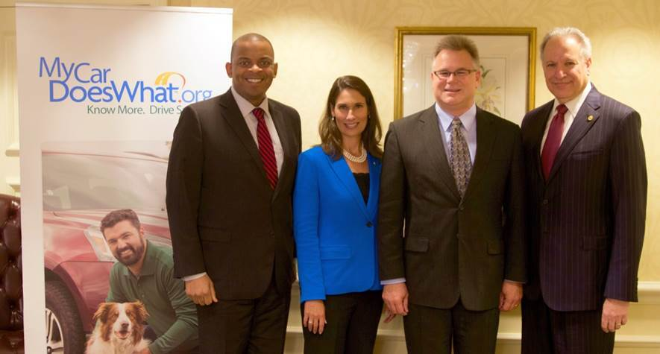
Figure 1.4. MyCarDoesWhat Launch Press Event. From left: Secretary of Transportation Anthony Foxx; National Safety Council President and CEO Deborah A.P. Hersman; Dr. Dan McGehee, director of the University of Iowa National Advanced Driver Simulator; Mark Rosekind, administrator of the National Highway Traffic Safety Administration

In addition to staff from the University of Iowa and NSC, representatives from a broad variety of auto, safety, government and media organizations attended in-person. These organizations included the Alliance of Automotive Manufacturers, General Motors, ABC News and the National Transportation Safety Board. This kick-off, with nationally recognized federal agency participation, provided an estimated 1,112,994,371 impressions in October 2015.
Launch support also included a full-page black-and-white ad which ran in USA Today, page 7, on October 7, 2015. The insertion generated 1.1 million impressions. This insertion was provided gratis as a result of overall campaign buys made by Qorvis MSL.
The event also spurred activity on social media (Figure 1.5).

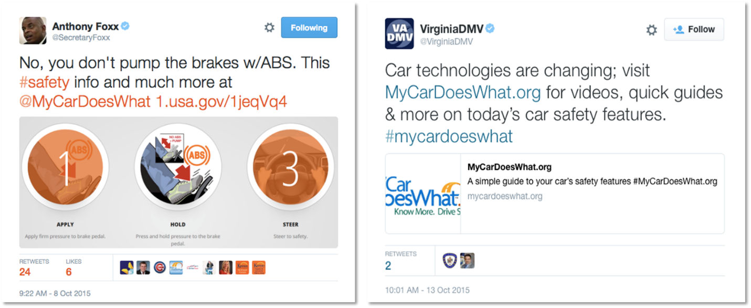

Figure 1.5. Top Tweets from MyCarDoesWhat Launch Event

Overview of Impressions Results
This evaluation document describes the results of the overall MyCarDoesWhat campaign in meeting its impressions and educational goals, in addition to the efforts to keep the campaign relevant and fresh. The following is a preview of the various strategies used to meet these impressions goals. The document is arranged to describe the three primary ways in which the campaign reached its goal – paid media (including social media and the public service announcement), earned media and owned media.
The MyCarDoesWhat campaign has secured 5.8 billion impressions (through November 2016), more than double the original court goal of 2.5 billion impressions. These impressions were achieved through earned media, paid media, events/owned media, and earned and paid social media. See Table 1.5 for impressions gained by type of media.

Table 1.5

Total Impressions, Campaign Lifetime, Through November 2016

Type of Media | Impressions
Evaluation Chapter Two
Earned Media | 4,975,359,404
Evaluation Chapter Three
Paid Social | 123,283,450
Paid Media | 700,884,696
Public Service Announcement | 11,907,996
Evaluation Chapter Four
Owned Media | 977,844
Total Impressions Reached | 5,812,413,390

CHAPTER TWO: PAID MEDIA

Paid media refers to content and advertisements designed to direct audiences to the campaign’s educational materials. Some paid media content itself is educational. The primary metric associated with digital and traditional advertising media is media impressions (MM), which refers to any time someone was exposed to the advertising content.
Evaluating the success of digital and traditional advertising media helps show how many people were exposed to the campaign and the concept that there exists an educational resource on advanced driver assistance systems. Exposure to the MyCarDoesWhat brand – its name, logo and tagline – is also important as it introduces the campaign as a known resource on this topic to audiences. See Figure 2.1 for media penetration by regional market.

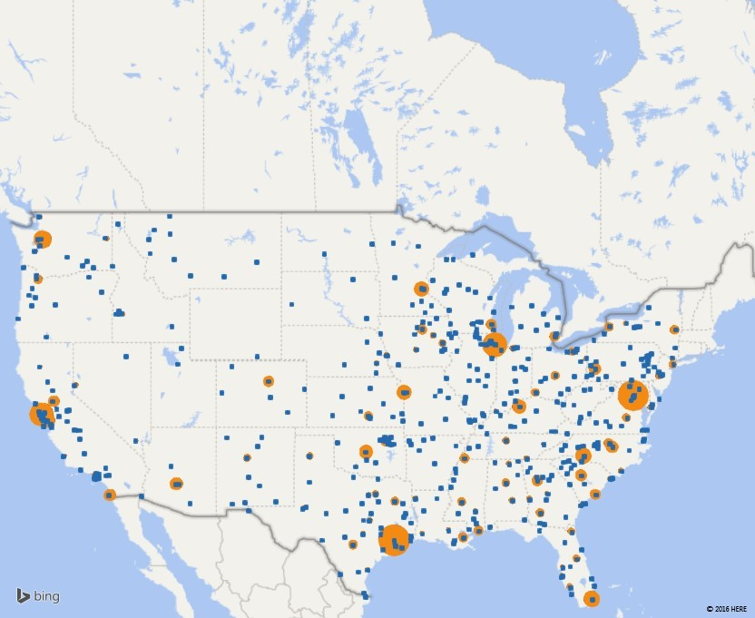
Figure 2.1. Regional Market Penetration of MyCarDoesWhat Mass Media Campaign

Media Strategies in 2015
To continue to build momentum around the educational campaign and to attract people to MyCarDoesWhat.org, a variety of media strategies were employed the following months between October and December 2015. This fourth quarter 2015 spend exceeded $1 MM. This was the highest level of quarterly expenditure and was designed to boost the awareness of the campaign at kickoff.
Table 2.1 describes the key benefits of the various types of media strategies used for the MyCarDoesWhat campaign.

Table 2.1
Media Strategies and Benefits
Media Channel | Benefits
Out of Home (Gas Station) | - Leverage channels 100% targeted to drivers while they are not in motion  - Proof of performance-audited impression numbers  - Can reach top markets-Top 12 U.S. markets, 33% U.S. coverage
Radio | - Connects with motorists in their vehicle while their safety is top of mind  - Covers 98% of the U.S., in 200 markets
TV and Print Public Service Announcement | - No cost  - Value-add impressions
Digital & Search Ads | - Targets audience  - Drives quality traffic back to website  - Helps with efficiency and engagement

Out of Home
The campaign hosted 15 second videos with advertiser Gas Station TV in the top 12 U.S. markets, offering 33 percent U.S. coverage. The videos played at gas pumps to engage drivers while they were filling up their cars. The videos ran within custom content featuring ESPN, Bloomberg TV, CNN’s Headline News and The Buzz Today, and local-hosted AccuWeather. This schedule alone delivered an estimated 27.3 million additional impressions.
Concurrently, MyCarDoesWhat was featured at the gas pump – when drivers were filling up their gas tanks – with 480 units of gas station toppers (see photos below). This program provided an estimated 103 million impressions with bonus 8” x 8” window clings on the front doors of the gas stations (where available) and :15 gas station radio (where available) at 1,278 gas stations (Figure 2.2).
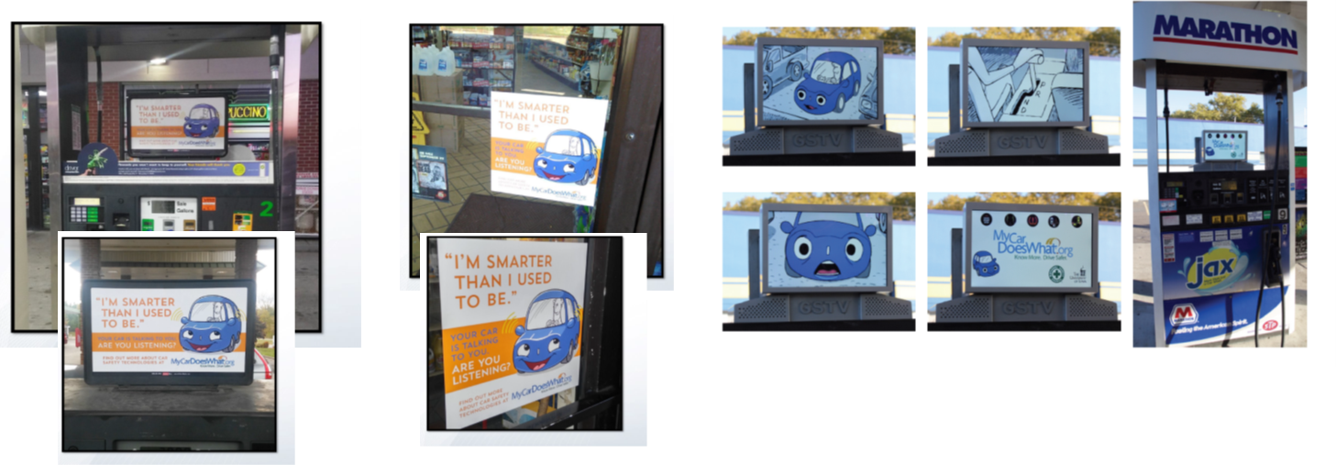
Figure 2.2. Examples of Out of Home Advertisements

Radio
Separately, to gain additional reach at launch, :15 pre-recorded ads were inserted into the news/traffic/weather segment of more than 2,100 radio stations in 200 markets. This effort connected with the motorist in their vehicle while their safety is top of mind.

TV and Print PSA
The PSA effort was complimented with a TV PSA distributed to cable and broadcast partners. These included ABC, CBS, NBC, FOX, CW, A&E Networks, Discovery, Turner, Lifetime, Scripps and Viacom. The PSA’s were shown at no cost and offered value-added impressions.

Online Paid Media
An online paid media buy was leveraged to reach U.S. motorists. These ads, which were shown while users browsed the web or used certain smartphone apps, were targeted via behavioral vendors to those searching for automotive parts and accessories, vehicle safety and security, travel, maps, auto repairs, new vehicles, and more. These ads were served to those seeking automotive information in the hopes of driving more quality traffic back to the website (Figure 2.3).

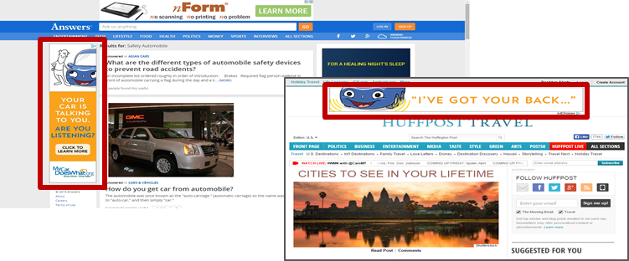

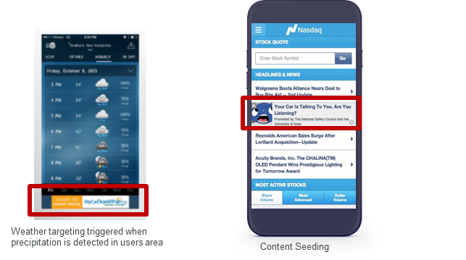

Figure 2.3. Examples of Online Paid Media Advertisements

Other Tactics
Other tactics employed included static billboards in key markets which ran in the time period April 11, 2015 to June 5, 2016 (Figure 2.4). The markets included Detroit/Ann Arbor, Chicago/Itasca, Iowa City/Des Moines, Bloomington/Normal, Illinois, San Francisco/Silicon Valley, Seattle, and Washington D.C. Audiences to be captured included automakers, insurance companies and potential partners. Figure 1.8 shows an example of an outdoor advertisement and a convention advertisement.

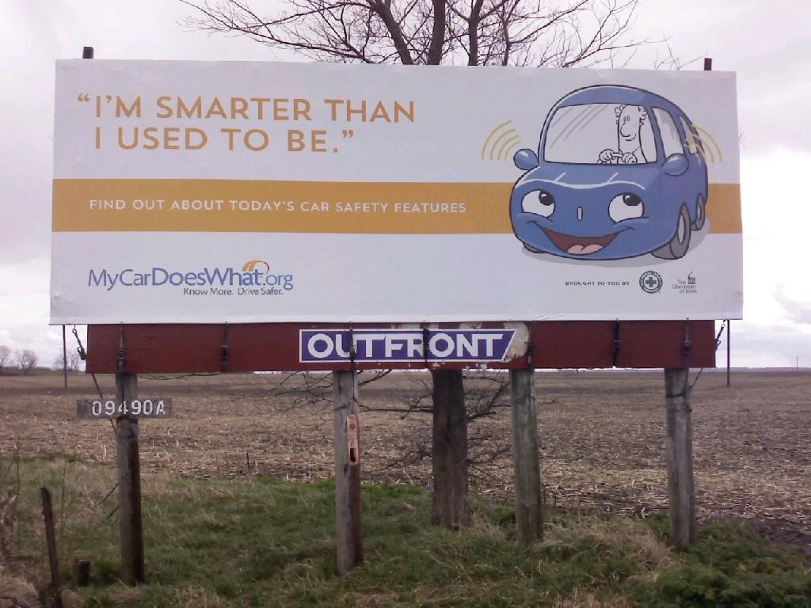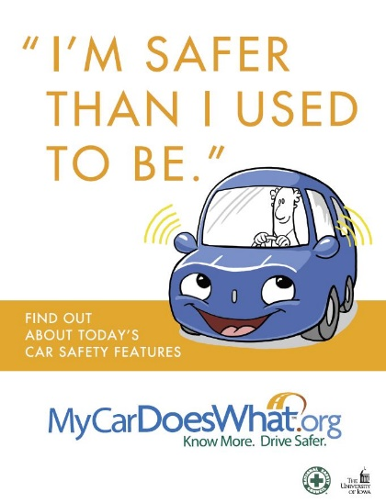

Figure 2.4. Outdoor Advertisement (left) and Convention Advertisement (right)

Paid Social Media
Paid and earned social media outreach were keys aspects of the campaign.

- Paid social media refers to impressions and engagements that resulted from paid advertising through the campaign’s social media channels or through content distribution services that delivered social media and blog content to audiences.
- Earned social media refers to impressions and engagements that were not the direct result of a paid ad on a social media network or content distribution service. However, impressions and engagements earned on social media are indirectly influenced by paid social media efforts.

Facebook and Twitter were the primary methods to build the campaign’s social media audience, with robust content and frequent updates. In the second phase of the campaign’s marketing and content strategy, blogs were added to the MyCarDoesWhat website.

The social media campaign soft launched in June, 2015, with paid (“boosted”) social media advertising beginning in July, 2015. By the campaign’s hard launch in October 2015, there were 14,997 Facebook fans. By Nov. 18, 2016, this fan base doubled to 36,014.

More important than the fans are those who saw or engaged with the content. To date, 437,474 unique users have clicked on a Facebook “story” (a post on the MyCarDoesWhat Facebook page) or created a story on their own pages by interacting with the MyCarDoesWhat Facebook page. In total, 418 different posts were crafted. Posts drove 5,525,973 total post impressions, with 5,029,972 of impressions via paid advertising on Facebook.

Sharing of the Facebook posts and content increased our reach even further, bringing the total number of impressions to 14,757,696.

Types of engagement include:
- Video Views: 984,741
- Comments: 1,777
- Likes: 31,485
- Shares: 5,269
- Click To-Play: 90,164
- Link Clicks: 37,519
- Other Clicks: 14,233
- Photo Views: 5,089

While Twitter was not a primary focus for MyCarDoesWhat, the platform was used for 310 tweets over the course of the campaign.

Those tweets drove:
- Earned impressions: 2,261,300
- Engagements: 4,961
- Retweets: 1,299
- Replies: 176
- Likes: 2,005
- Link Clicks: 1,481

Audience Segmentation
An additional strategy of appealing to four discrete audience segments was developed and implemented. Data was indicating that an appeal to discrete segments might increase engagement. This also is an example of the campaign’s efforts to stay current with marketing trends keep its materials fresh. The audiences chosen were those we believed were more naturally interested in the topic of the campaign.
While the budget did not exist to reach many distinct audience segments, the University of Iowa, Qorvis MSLGROUP and the National Safety Council (NSC) agreed on trying to reach audiences in a more specific way. Four audience segments were identified and paired with new online and smartphone app advertisements, behavioral targeting vendors and accompanying “landing pages” on MyCarDoesWhat.org (Figure 2.5). The segments and content were:
- Moms with young children (Getting You Home Safety)
- Tech Savvy/Gadget Geeks (My Car Thinks I Am a Secret Agent)
- Auto Enthusiasts (Car Nut)
- New Vehicle Shopper (Evolution)
This targeting strategy helped:

- Narrowcast versus broadcast
- Divide the audience into a series of definable sub-groups
- Contextualize the messages to connect emotionally with each specific group
- Reach these audiences where they are
- Speak in their language with specifically-designed landing pages for each audience

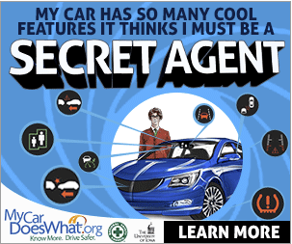
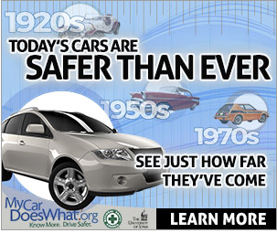
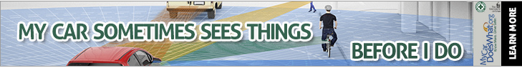
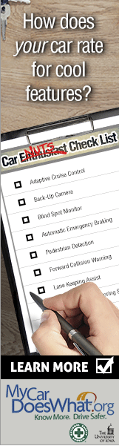
Figure 2.5. Examples of Landing Pages and Ads by Targeted Audience

To reach each segment, a tactic of using digital banner ads was deployed, supported by unique landing pages which allowed the team to analyze what ads were working. Adjustments were made each month to maximize viewers and clicks to MyCarDoesWhat.org. The team monitored cost-per-click and click-through-rates, modifying our schedule to maximize the most efficient delivery for the dollars invested.
Separately, as part of the paid media program targeting leading thinkers in the vehicle automation space, print ads were placed in the July 2016 onsite program for the Association for Unmanned Vehicle Systems International and the Fall 2016 American Association of Motor Vehicle Administrators magazines.

Topline Results
Paid media contributed 700,884,696 media impressions to the campaign’s impression total. Additionally, placements of the public service announcement added 11,907,966 impressions to the campaign’s total impressions. Paid social media advertisement contributed 123,283,450 impressions. Earned social media impressions are described in later parts of this document.

CHAPTER THREE: EARNED MEDIA

Earned media contributed the most impressions to the campaign at nearly 5 billion. Earned media is the exposure received by the campaign in coverage was not paid for. Typically, these impressions were the result of news stories, press releases and other activities, such as The University of Iowa showcasing the campaign in their Mobile Museum which covered 36 counties and traveled more than 9,000 miles in the summer of 2016.
Print outlets carrying stories about the campaign ranged from the AP, to the NYT, Chicago Tribune, Seattle Times, Washington Post, Boston Globe, Huffington Post, Yahoo News, Kansas City Star, The Auto Channel, Motor Trend.
Broadcast Outlets doing stories were frequently sparked by Debbie Hersman and Dan McGehee doing radio and television satellite media tours:
Several satellite and radio media tours to reach drivers were scheduled including:
- July 4, 2015 RMT about travel tips with Deborah Hersman and Dan McGehee
  - Top hits:
    - 24/7 News Source – June 29, AQH: 3,000,000
    - Associated Press Radio – June 29, AQH: 1,860,000
    - Georgia News Network, June 29, AQH: 81,000
    - American Urban Radio – June 30, AQH: 1,500,000
    - Illinois News Connection – June 30, AQH: 90,000
    - Bobby Likis Car Clinic – July 2, AQH: 165,000

*AQH is an abbreviation for Average Quarter Hour Persons indicating the average number of persons in a demographic group listening to a particular radio station for at least five minutes during an average 15-minute segment of a given day-part - the “snapshot” of an audience.

- Oct. 8, 2015 SMT with Deborah Hersman about the campaign launch
  - Top hits:
    - CBS News path (impressions N/A)
    - NBC News Channel (also feeder) – Estimated audience: 551,811
    - WTHR-TV (Indianapolis) – Audience: 53,071
    - KUSA-TV (Denver) – Audience: 41,820
    - WBBM-TV (Chicago) – Audience: 21,203

- An additional satellite media tour with Deborah Hersman and a radio tour with Dan McGehee occurred in early December to focus on winter weather driving.

To reach drivers and automotive influencers, MyCarDoesWhat hosted briefings with automotive press association groups across the country. The press association events generated positive coverage and raised awareness of MyCarDoesWhat among leading automotive journalists, who then began including the website and campaign in articles as a reference for drivers.

The campaign hosted the following press association events:

- Washington Automotive Press Association (WAPA) – Jan. 27, 2016
- Automotive Press Association (APA) – March 1, 2016
- Midwest Automotive Media Association (MAMA) – April 6, 2016
- Western Automotive Journalists (WAJ) – July 21, 2016
- International Motor Press Association (IMPA) – Nov. 2, 2016

Key spokespeople at relevant industry and safety events leveraged timely news hooks and issued statements to ensure the MyCarDoesWhat campaign was inserted into news stories.

To share tips with drivers and promote the campaign’s educational tools online and in community newspapers, a series of matte releases were placed in community newspapers across the country. Topics and related impressions were as follows:
- 100 Deadly Days – June 2015: 70,476,115 impressions
- MyCarDoesWhat launch – Oct. 2015: 74,631,557 impressions
- Winter weather driving – Dec. 2015: 71,882,056 impressions
- Winter weather driving – Dec. 2016: TBD

As far as the mainstream and automotive media, numerous top-tier media hits were secured throughout the campaign. The media also began referencing the MyCarDoesWhat website as a helpful, credible resource for drivers. See Appendix B for notable media coverage of the campaign. Below are some examples of quotes:

- “The site uses clear, concise explanations…” – Edmunds.com
- “…simple, straightforward and useful information…” – Kelly Blue Book
- “This site can also come in handy when you are shopping for a new car” – The Manual
- “Better familiarize yourself with safety features” – WardsAuto

Many reputable national and regional newspapers, magazines and other print media outlets ran stories about the campaign. This provided content for an integrated effort in social media and established the campaign as a resource for drivers, media, original equipment manufacturers and policy leaders. It also opens the door for partnerships and possible future funders.

Additionally, the campaign has been honored with multiple awards:
- North American Excellence Award for Association
- Thoth Award Certificate of Excellence for Public Service
- Platinum PR Award for PSA
- Platinum PR Award for Public Affairs (finalist)
- International Communications Consultancy Organisation for Non-profit (finalist)
See Appendix C for a list of key speaking engagements and other events in support of the campaign.

CHAPTER FOUR: OWNED MEDIA (PRIMARY EDUCATION CHANNEL)

Owned media refers to the audience’s exposure to the educational materials produced for the MyCarDoesWhat campaign. Some of the key metrics used to evaluate the owned media in the campaign include impressions, engagement, effectiveness of the website and estimated perception change among U.S. social media users.
Overall, the campaign’s owned media – including the website, social media accounts, games and app – contributed 977,844 impressions to the campaign’s overall impressions goal. Separately, paid social media contributed 123,283,450 impressions to the overall impressions goal.

Website (MyCarDoesWhat.org)
The primary data collection source for website analytics in the MyCarDoesWhat campaign is Google Analytics Universal (GAU). GAU tracks a variety of website metrics, including the number of site visitors, how many of those visitors are new or returning, and how long do visitors stay or engage with the site.
Thus, GAU can help answer questions such as the following:
- How many people are visiting MyCarDoesWhat.org?
- How are people reaching MyCarDoesWhat.org?
- How many people are downloading materials from MyCardoesWhat.org?
This category also includes Add This, a program that can track when users share individual pages from the website. This helps answer questions about whether citizens are sharing information about crash avoidance technologies with their networks.
The MyCarDoesWhat website’s most successful pages are the “landing page” – those to which visitors are referred from various advertising outlets. For example, the homepage – https://mycardoeswhat.org – is where visitors arrive when they type in the name of the campaign into their web browser. Since it is the default page that opens first when visiting the site, it is consistently the page with the highest number of views.
Another popular landing page is the Videos and Graphics page – https://mycardoeswhat.org/videos-and-graphics/ – which provides users a repository of the audiovisual content available from the campaign. Many links used on social media that direct users back to the website direct them to this page instead of the default homepage because many users of social media platforms use their content for entertainment purposes rather than information seeking.
The core content of MyCarDoesWhat.org, however, is the collection of individual pages of advanced driver assistance systems. All features are accessible through a scrolling list on the homepage, through a dedicated safety features listing page and through an ever-present scrollable list located on the left side of the screen.
Visitors also arrived at MyCarDoesWhat.org throughout multiple means. This data is captured by GAU and can be used to track the effectiveness of the various advertising methods used in the campaign.

Mid-Campaign and Iterative Evaluations
The campaign’s directors and designers kept track of the website’s metrics on a regular basis. Key indicators tracked included the overall website traffic, engagement with the site and sources of traffic. This continual tracking of the website’s metrics led to many minor adjustments throughout the campaign. The most significant adjustments included the following:
- Adjusting the mobile version of the website to show all active safety feature page content by default rather than having users’ select which sections to view by tapping
- Moving the website to a different server after it was discovered many users were encountering far-beyond average page loading times
- Reformatting individual blog pages to provide more opportunities to explore the rest of the site after blogs began receiving large proportion of website traffic in late 2016
- Redesigning the “Videos and Graphics” content library page upon discovering high traffic but low engagement with the page in its original design
- Swapping out previous images on the website’s homepage to help prevent fatigue

Website Intercept Surveys
Website intercept surveys are unique from traditional survey in that the target population is delivered a survey only when they are currently being exposed to the intervention being tested. MyCarDoesWhat.org uses such a software, called iPerceptions, to survey visitors under set circumstances. These typically include visitors who have been on the website longer than a set period of time (such as 45 seconds) or visitors who have clicked through at least more than one page.
By asking actual website visitors questions, the evaluators used iPerceptions to test whether users are gaining knowledge over time as well as ask users a variety of questions about the purpose of their visit and their intentions with the information they found on the site. This directly assisted in the campaign’s mid-campaign formative evaluation as well as other website improvement efforts throughout the campaign.

Mid-Campaign Formative Evaluation
A formative mid-campaign evaluation, which gathered all available metrics and open-ended feedback, resulted in more significant changes to the website. This formative evaluation gathered quantitative metrics from the website’s traffic and usability reports and compared them with industry benchmarks. The evaluators, in tandem, used qualitative feedback from the website’s surveys, feedback forms, live recordings of visitor visits and page sharing behavior to better understand the quantitative metrics they found.
This mixed-methods approach identified challenges in the website’s engagement, traffic patterns and overall usability. Some of this data, which included sources of traffic, helped inform the marketing mix deployed by the team. The engagement data directly informed the development of additional blog content because the blogs were receiving much higher-than-average audience retention compared with the rest of the site.
More information on the mid-campaign evaluation can be found at either https://nscftp.nsc.org/public/file/ruDqN_hdxkqGoqDUoDmDCw/Website%20Efficacy%20PPT_vFinal_APHA.pdf or https://mycardoeswhat.org/wp-content/uploads/2016/12/Website-Efficacy-PPT_vFinal_APHA.pdf.

Website Topline Results
Qorvis MSLGROUP reported the campaign drove a total of 619,567 visitors to the MyCarDoesWhat website and educational tools covering 30 safety features.

Table 4.1 and Figure 4.1 illustrate growth in the number of visitors to MyCarDoesWhat.org as a result of the campaign’s marketing efforts. Traffic to the site increased dramatically from 2015 to 2016. The number of sessions climbed 213 percent while users increased 211 percent and page views climbed 135 percent.

According to Google Analytics Universal’s benchmarking tool, the average bounce rate for “How-To, DIY & Expert Content” reference websites is about 64 percent for self-reporting sites with a similar amount of traffic as MyCarDoesWhat.org. Bounce rate is typically an indicator of interest in the topic once a user lands on the page. However, early on, it was determined that our typical user visited only the page they were interested in for a quick answer to their question. The time on page indicates a healthy interest in content.

The mass media campaign tactics used attracted users initially. In efforts to get users to the educational component, the mass media tactics used have a tendency to draw higher traffic but less quality and engaged visitors.

Table 4.1

Website Traffic Metrics Between 2015 and 2016

Metric | 2015 | 2016
Sessions | 155,630 | 487,835
Users | 129,560 | 403,475
Page Views | 300,112 | 705,494
Avg. Session Duration | 00:01:40 | 00:00:54
Bounce Rate | 64.85% | 81.95%
New Sessions | 82.55% | 83.25%

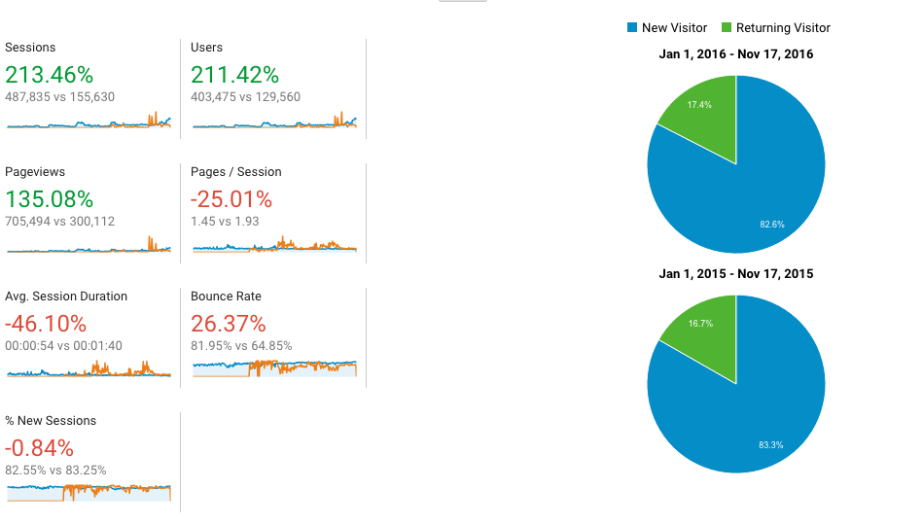
Figure 4.1. Lifetime Website Traffic to MyCarDoesWhat.org. This chart shows a variety of website metrics encompassing the lifetime of the website during the lifespan of the MyCarDoesWhat campaign under the Toyota Economic Loss Settlement, in addition to changes in metrics between 2015 and 2016, with metrics shown in green representing increases between years and red representing decreases. View more information about the metrics at https://developers.google.com/analytics/devguides/reporting/core/dimsmets.

Owned (Organic) Social Media
As mentioned previously, MyCarDoesWhat had a strong social media component in both the media marketing strategy and the content produced. The “Paid Media” section provides more extensive details on the strategies used around social media.
The primary data sources for this category are the native analytics platforms for the social media platforms used to deliver campaign messages. These are Facebook Insights, Twitter Analytics and YouTube Analytics.
These analytics tools allow the evaluators to answer a variety of questions, including how frequently users share information with their personal or professional networks and how engaged users are with MyCarDoesWhat campaign materials.
Engagement can be defined by a variety of user actions, such as sharing a post (ReTweeting on Twitter), subscribing to videos, newsletters or status updates, how much time users have spent watching campaign videos, and many more.
The majority of the impressions gained from social media were due to paid (or “boosted”) content, which was discussed in the “Paid Media” section of this document. Among organic social media content, posts that mention other transportation leaders tended to do the best. The Tweets in Table 4.2 were the best-performing Tweets in the initial phase of the MyCarDoesWhat campaign.

Table 4.2
Top Tweets during MyCarDoesWhat Campaign
Date Range | Tweet | Tweet Date | Impressions | Engagements | Engagement Rate
7/28/15-10/26/15 | "If drivers do not understand & accept the technologies in their cars, we will miss their life-saving opportunities"- @NHTSAgov's Rosekind | 10/7/2015 | 14582 | 52 | 0.40%
7/28/15-10/26/15 | LIVE: "As we advance [safety] technologies, we also need to advance driver knowledge of how to use them" - @SecretaryFoxx #MyCarDoesWhat | 10/7/2015 | 13111 | 67 | 0.50%
1/26/16-4/25/16 | New to #MyCarDoesWhat: @NTSB's Honorable T. Bella Dinh-Zarr discusses the importance of cars as a #publichealth tool http://vrl.ht/A4089 | 4/25/2016 | 10828 (organic) | 32 | 0.30%
7/28/15-10/26/15 | Don't be afraid of driving in the dark! Adaptive headlights are here to light your way: http://bit.ly/1SL0Qcr | 8/7/2016 | 5468 | 7 | 0.10%
10/27/15-1/25/16 | #DidYouKnow: Back-up cameras will be mandatory on all new cars in 2018. Learn more: mycardoeswhat.org/safety-feature… pic.twitter.com/Ui5pKm18EJ | 12/7/2015 | 3580 (organic) | 55 | 1.50%

Formative Evaluation
As social media was a key – sometimes leading – source of traffic to MyCarDoesWhat.org, the campaign’s directors and designers regularly checked its effectiveness and how it was being received by the public.
A mid-campaign evaluation took place to evaluate what types of social media posts and content have the highest rates of engagement and clicks to the website. These findings were captured and delivered to the MyCarDoesWhat content creators and campaign directors.
Among the dimensions of posts evaluated were the design of posts themselves, including length of text and placement of links; the tone or editorial direction of posts, if present; and the types of audiovisual or static image content attached to posts.
Then, among the key performance indicators evaluated:
- Campaign impressions gained per post
- Engagements with social media posts, such as reactions, comments and shares
- The quality of traffic generated to the website as a result of the post, with quality defined as engagement (time spent on site, pages viewed, return visits to the site)
For the results and more information on the mid-campaign social media evaluation, see either https://nscftp.nsc.org/public/file/BcJy_iTXZEOm10txcaSF_A/Social-Media-Formative-Evaluation-Faust_FINAL.pptx or https://mycardoeswhat.org/wp-content/uploads/2016/12/Social-Media-Formative-Evaluation-Faust_FINAL.pptx.

Campaign Blog and Underused Long-Form Content
In Phase 2 of the campaign, the MyCarDoesWhat blog launched. Numerous posts and third-party contributed content were contributed to expand the campaign’s reach and amplify the campaign’s messages.

In addition the campaign authored almost 20 posts (still visible online) which included a variety of topics ranging from Dashing Through the Snow to YOU are still your car’s best safety feature.

Qorvis MSLGROUP subsequently audited the MyCarDoesWhat site to identify high-value and underutilized long-form content. The team deployed a content engine known as Outbrain, a service that partners with high-value media websites to provide a “recommended content” section in the footer of each of the stories. This placement presents users with up to nine stories to continue reading once they have finished reading their article. Media outlets’ websites’ served by Outbrain include Fox News, ABC, MSN, ESPN, CNN and The Washington Post.

The Outbrain campaign helped drive a surge in traffic to the MyCarDoesWhat site in only two months, delivering:
- 28,207,829 impressions
- 42,354 clicks

Videos
A key source of content across all forms of media in the MyCarDoesWhat campaign is video. There were three primary types of videos produced for the MyCarDoesWhat campaign. The videos in Table 4.3 were the campaign’s best-performing videos other than the video public service announcement.
- Educational videos – These live-action and animated video clips are designed to educate the audience about a particular advanced driver assistance system or related concept. These most apply to the actual knowledge change goals of the campaign.
- Marketing videos and public service announcement – These video clips were designed to draw users to the MyCarDoesWhat.org website, which they can then use to learn more about using advanced driver assistance systems safely. More information about the public service announcement can be found in the “Paid Media” section.
- Social media vignettes – These videos are designed in a way to match the expectations of a social media-using audience. They are neither purely about educating the audience nor marketing the rest of the campaign. Within themselves, they are entertaining and may happen to promote the campaign name. These videos are above-and-beyond the most viewed of the campaign. The following are the most popular social media vignettes produced so far.

Table 4.3: Top Campaign Videos Other Than Public Service Announcement
Post Content | Video link | Post date | Views | Lifetime Engaged Users
A video introduction to the campaign | https://www.facebook.com/MyCarDoesWhat/videos/600362700142911/ | 7/14/16 | 328,645 | 2,006
A vignette demonstrating how back-up cameras help drivers back up safer | https://www.facebook.com/MyCarDoesWhat/videos/658011234378057/ | 11/10/16 | 319,749 | 19,508
A comedic monologue on the difficulties of parallel parking, and how an active safety feature can help | https://www.facebook.com/MyCarDoesWhat/videos/656719791173868/ | 11/11/16 | 198,559 | 17,740
A group of women aged 70 and older discuss active safety features | https://www.facebook.com/MyCarDoesWhat/videos/641631949349319/ | 10/31/16 | 193,801 | 3,968
A video demonstration of the active safety feature adaptive cruise control | https://www.facebook.com/MyCarDoesWhat/videos/641173896061791/ | 10/11/16 | 174,417 | 13,063

The team made another creative turn by including a series of videos hosted by a young PhD candidate from the University of Wisconsin, Madison Department of Industrial and Systems Engineering (Figure 4.2). She spoke in layman’s language about multiple active safety systems. This was a way of providing more technical background for those who wanted to dig a little deeper into the subject matter.

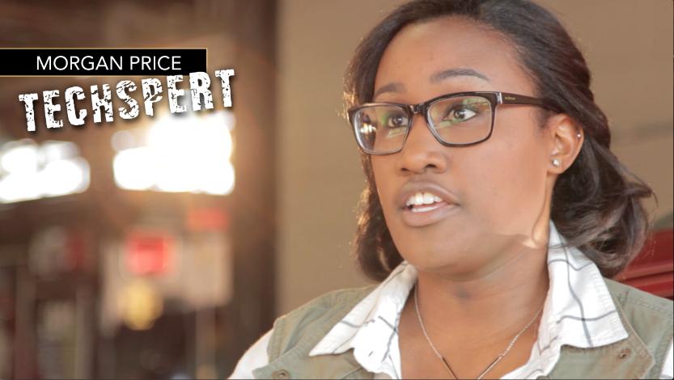
Figure 4.2. Morgan Price’s Techspert Video Series for MyCarDoesWhat

NSC also developed video targeted to senior citizens taping a group of real 70+ aged Chicago women about what they knew, or did not know about new car technology. We labeled that series, “Savvy Seniors” (Figure 4.3).

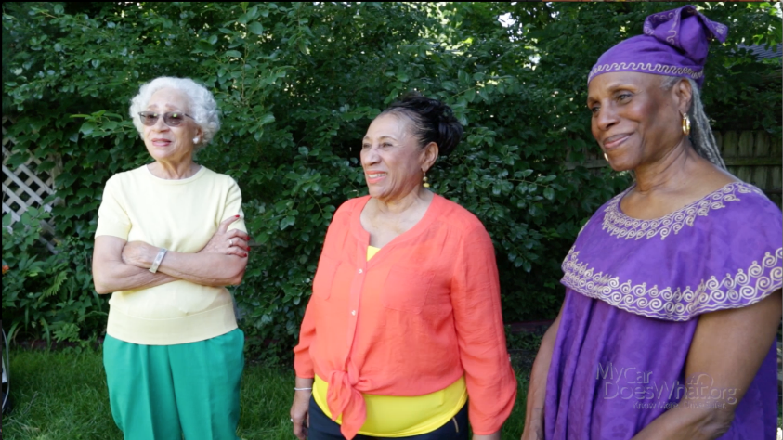
Figure 4.3. Still from Savvy Seniors Video Series

New creative was developed by the in-house team using different styles and content to encourage visits. This media was delivered through social media. This included My Car Babies, Bridget Curbside, Sing along with the Icons, messages with captioning and no audio, animation, virtual reality, a Dan McGehee in “Six Tips in 60 Seconds” (Figure 4.4).
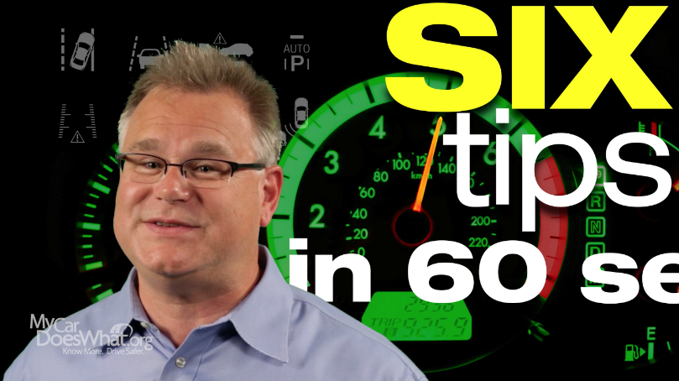
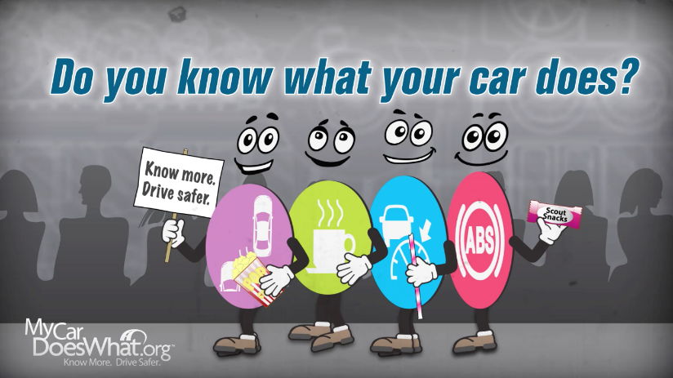
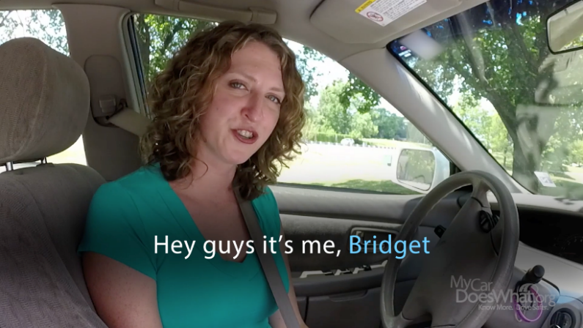
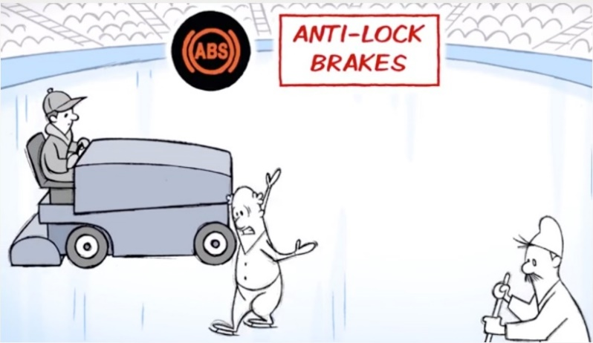
Figure 4.4. Video Stills from MyCarDoesWhat Social Media Series

Games and App
In addition to videos, graphics, social media posts, a website and other public-facing materials, MyCarDoesWhat also offered visitors the opportunity to learn through interactive experiences. These include a fun quiz to assess what crash avoidance technology a visitor resembles; a puzzle game featuring crash avoidance technology icons; and an interactive phone and tablet app that allows users to run a digital car show about advanced driver assistance systems.
Each game is designed to have educational elements as well encourage players to visit MyCarDoesWhat and share the site with others. Each game or quiz provides analytics on how many people have played them and for how long. These analytics can help answer various questions about how the campaign teaches citizens about crash avoidance technologies.

Game and App Topline Results
Dashboard Blitz was downloaded 188 times through the Apple App Store and 96 times through the Google Play store throughout the life of the campaign, for a total of 284 downloads.
The first Facebook game, What Dashboard Icon Are You Today?, was played 6,961 times over the campaign. The second Facebook game, Dashboard Scramble, was played 1,030 times.

Resulting Demographics of Campaign’s Owned Media Audiences
Many of the campaign’s metric tracking tools also capture some demographic information of the audience in addition to impressions earned and engagement with the content. Due to widely different privacy settings across the Internet and digital media sources, demographic information was not available for all owned content in the campaign. Also, only a few overall types of demographic data are made available by these platforms – age ranges of visitors, biological sex (reported as gender) and type of device used to access the campaign’s owned content. Geographical information provided by the platforms was difficult to obtain due to users’ privacy settings.

Age Group
Older visitors encompassed a higher proportion of the audience than younger visitors across MyCarDoesWhat.org and Facebook, with the highest proportion of visitors coming from age groups 65+ (23.14%) for Facebook and 55-64 (18.72%) for Twitter. The audience for the campaign Twitter and YouTube platforms, however, had a higher proportion of younger visitors as opposed to older visitors. Campaign Twitter page and YouTube channel visitors both had highest levels of representation from age group 25-34 (29%) compared to other age groups represented by the data. Age group representation was more evenly distributed for the main campaign website compared to campaign Facebook, Twitter, and YouTube pages. See Figures 4.5, 4.6, 4.7 and 4.8.

Figure 4.5.

Figure 4.6.

Figure 4.7.

Figure 4.8.

Age Demographic Comparisons with Platform Reported Averages
On the campaign’s social networking platforms, Twitter and Facebook, the results do not fully reflect the normal proportions of the seven age groups on either site (Table 4.4). Visitors aged 55-64 had highest proportional representation for the campaign Facebook page (18.72%), but visitors aged 18 to 24 had highest proportional representation for Facebook overall (33%). This trend continued for Twitter as well.
Visitors aged 25-34 had highest proportional representation for the campaign Twitter page (29%), but visitors aged 18 to 24 again had highest proportional representation for Twitter overall (38%). Age range representation was fairly even for the MyCarDoesWhat campaign Facebook page, a contrast to Facebook as a whole, whose representation was skewed toward younger users. Age distributions for both campaign and overall Twitter use were more similar to one another, although representation also tended to be skewed towards younger users. See Figures 4.9, 4.10 and 4.11.

Table 4.4
User Age by Campaign Platform’s Reported Average User Age
Age range | Facebook |  | Twitter
 | Campaign | Average | Campaign | Average
13-17 | 3.71% | N/A | 11% | 16%
18-24 | 13.01% | 33% | 17% | 38%
25-34 | 15.28% | 30% | 29% | 26%
35-44 | 15.32% | 17% | 20% | 10%
45-54 | 16.80% | 11% | 15% | 7%
55-64 | 18.72% | 6% | 5% | 1%
65+ | 16.99% | 4% | 2% | <1%

Figure 4.9.

Figure 4.10.

Figure 4.11.

Biological Sex (Gender)
Males encompassed a higher proportion of the audience than females across the main owned digital platforms – MyCarDoesWhat.org (68% to 32%), Facebook (62% to 38%), Twitter (55% to 45%) and YouTube (66.5% to 33.5%). (See Table 4.5.) The discrepancy was highest on MyCarDoesWhat.org, which partially determines biological sex based on a sample of Google+ data of website visitors. Facebook, Twitter and YouTube collect biological sex data through users’ self-identification. See Figures 4.12, 4.13 and 4.14.

Table 4.5
Biological Sex (Gender) By Owned Media Platform
Gender (biological sex) | MyCarDoesWhat Website | Facebook | Twitter | YouTube
Male | 68.42% | 62% | 55% | 66.50%
Female | 31.58% | 38% | 45% | 33.50%

Figure 4.12.

On the campaign’s social networking platforms, Twitter and Facebook, the results do not fully reflect the normal proportions of males to females on Facebook but match closely with normal proportions on Twitter (Table 4.6). The average proportion on Facebook is 55% to 45% compared with a 62% to 32% proportion on the MyCarDoesWhat Facebook page, a difference of 20%. Both MyCarDoesWhat Facebook and Twitter pages had more uneven rates of gender representation than Facebook and Twitter as a whole, although the gap was slightly narrower for Twitter users.

Table 4.6
Biological Sex (Gender) by Campaign Platform vs Platform Reported Averages
Biological Sex (Gender) | Facebook |  | Twitter
 | MyCarDoesWhat | Facebook overall | MyCarDoesWhat | Twitter overall
Male | 62% | 55% | 55% | 48.98%
Female | 38% | 45% | 45% | 51.02%

Figure 4.13.

Figure 4.14.

Device Use
Mobile device use encompassed a higher proportion of devices used to access campaign platforms than other device types across three of the four main owned digital media platforms (Table 4.7). Approximately 77.21% of visitors to the main website used a mobile device (62.81 mobile phone, 14.40% tablet), compared with 22.78% of visitors using a desktop.
Facebook and YouTube also had a higher proportion of users accessing MyCarDoesWhat pages through mobile devices, with rates of 89.4% for Facebook’s current financial quarter and 68% (29% mobile phone, 39% tablet) for MyCarDoesWhat’s entire lifetime on YouTube. Twitter’s proportions of mobile use vs desktop use to access the campaign platform were 54% to 93%, respectively, but this includes the same users accessing the site from multiple devices. See Figures 4.15 and 4.16.

Table 4.7
Type of Device Used to Access Campaign Owned Content
Device type | MyCarDoesWhat | Facebook (current quarter only) | Twitter (same users using multiple devices) | YouTube
Mobile | 62.81% | 1,100 | 54% | 29%
Desktop | 22.78% | 131 | 93% | 27%
Tablet | 14.40% | x | x | 39%
Game Console | x | x | x | 2.90%
TV | x | x | x | 2.1%
Unknown | x | x | x | 0.30%

Figure 4.15.

Figure 4.16.

CHAPTER FIVE: OTHER EVALUATION TOOLS AND CONCLUSION

The following additional methods were used to help evaluate whether the campaign was reaching its intended educational goals.

Surveys
The following data sources are each surveys or questionnaires that attempt to determine the audience’s perception and understand of advanced driver safety systems – and, eventually, the effect of the MyCarDoesWhat campaign on the audience’s perceptions and understanding.

National Survey of Consumer Driver Safety
Please see University of Iowa full project report for this information

Advanced Vehicle Technology Consumer Survey
Please see University of Iowa full project report for this information

Website Efficacy Study
Two traditional online surveys (Pre & Post) were delivered to opt-in survey panelists, balanced to census on gender, age, region, income, and ethnicity. The pre-test survey collected baseline measures of panelists’ understanding of safe driving attitudes and behaviors, as well as knowledge of advanced driver assistance systems.
After the survey, respondents were sent directly to MyCarDoesWhat.org. A tracking cookie was placed on the respondent’s computer to verify when the actual website visit takes place. This cookie allowed the evaluators to know how much time people spend on the site and what pages they visited, allowing the evaluators to correlate time on site with change in perceptions and behavior.
The subsequent post-test survey was used to measure the impact of a visit to the MyCarDoesWhat.org website on safe driving attitudes and behaviors, as well as change in knowledge in understanding how certain advanced driver assistance systems work. See [INSERT LINK FROM MICHAEL HERE] for more information.

Partnerships, Collaboration and Sharing
Other sources provide the evaluation staff with crucial information about how MyCarDoesWhat campaign materials are being shared externally; how other organizations perceive the campaign; who wants to partner with the campaign; and other questions related to the campaign’s credibility and collaboration potential.
Partnerships was a key internal goal of the campaign – and the campaign was successful in forging new relationships with several organizations. The partnerships permitted MyCarDoesWhat to leverage each association’s social media followings, websites, newsletters and relationship to help publicize the campaign.
AAMVA – The first major partnership MyCarDoesWhat formed was with the American Association of Motor Vehicle Administrators. This is the organization of DMVs and State Law Enforcement for all 50 states and Canada. AAMVA endorsed our content by placing links on their website. Additionally, the State of Iowa DMVs started showing our educational materials at DMVs and rest stops around the state.
MyCarDoesWhat videos are now running, as a pilot test, in Iowa Department of Motor Vehicle locations (Figure 5.1).

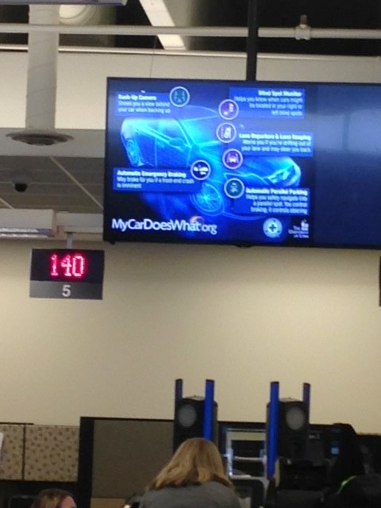
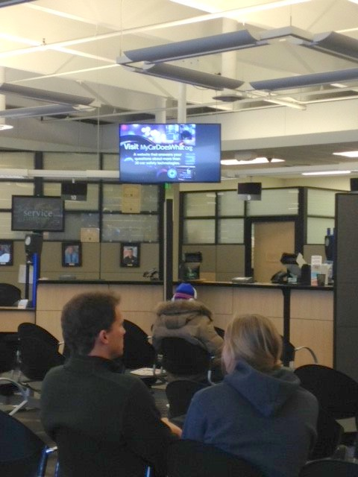

Figure 5.1. MyCarDoesWhat Content Shown at Department of Motor Vehicle Locations

As of December, 2016, additional DMVs have decided to show MyCarDoesWhat videos in their states, including NY, NC, SC, FL (State & 7 Counties), TX (Denton County), DE and PA.
NADA - The National Automobile Dealers Association invited MyCarDoesWhat to their annual convention to announce a partnership whereby dealers would begin to utilize materials to help the public, as well as dealership employees to become more educated about Advanced Driver Education Systems in vehicles (Figure 5.2).
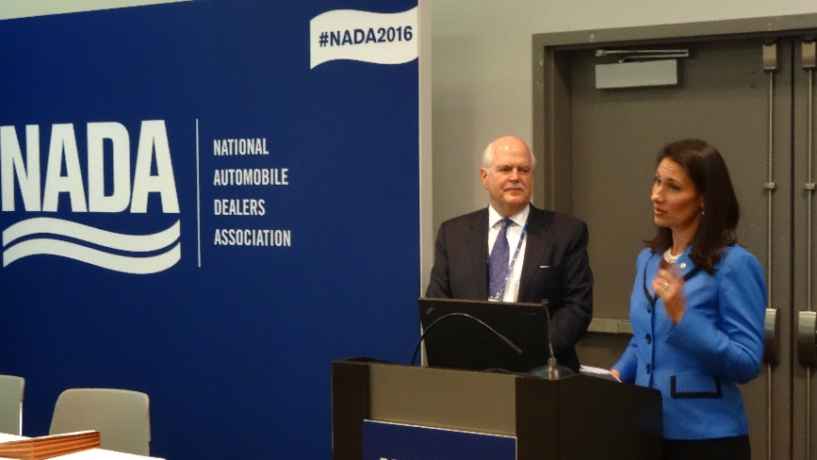

Figure 5.2. Press Event at the National Automobile Dealers Association. Left: ; Right: National Safety Council President and CEO Deborah A.P. Hersman.

ADTSEA – The American Driver and Traffic Safety Education Association has made a formal request of MyCarDoesWhat – to utilize some of our educational videos and graphics in the course work DVDs that are distributed to instructors nation-wide.

NSC – The National Safety Council is currently utilizing some of the MyCarDoesWhat videos in its Aliveat25 Driver education program – which reaches approximately, 75,000 teens and parents each year. Additionally, NSC expects to utilize educational materials as part of its Defensive Driving Courses when these are redone over the next 4 years – reaching a potential audience of 1.25 million drivers annually.

Social Media Listening
Crimson Hexagon’s ForSight platform is an advanced social media listening tool that allows users to search for key words and topics among hundreds of millions of social media posts over time. ForSight is used by the MyCarDoesWhat staff to track the amount of conversations about crash avoidance technologies over a set period of time, such as the year prior to and year after the campaign launch.
This allows the evaluators to answer questions such as “How often to people discuss crash avoidance technologies among others?” and “Are attitudes changing about crash avoidance technologies over time?”
More information about the results of the sentiment analysis can be viewed at https://mycardoeswhat.org/wp-content/uploads/2016/11/ADAS-Sentiment.pdf, as well as a press release on the study at http://www.nsc.org/Connect/NSCNewsReleases/Lists/Posts/Post.aspx?ID=160.

Additional Learnings and Next Steps
Through our work on the campaign, the team noticed several key points about active safety technologies that seemed to be cropping up frequently.
- Safety features have different brand names and even generic names
- Safety features have different capabilities across manufacturers, trim levels and time
- Safety feature limitations may not be intuitive or obvious
- Warning or icon standardization issues
- There is a lack of data sharing around efficacy of systems

These issues have been discussed frequently at conferences, with the goal of improving ways to more consistently name, identify, use and compare safety features across OEMs.
Meetings between the University of Iowa and National Safety Council leaders at the start of 2016 have begun to explore funding beyond the December 2016, the grant’s end date. The National Safety Council has agreed to extend the life of the campaign at least 6 months (through June 30, 2017) to enable work to continue as new funding sources are sought.
Additionally, since the general public is interested in the topic of higher levels of automation, we will consider expanding the mandate of the website to cover that topic.
We also are considering developing specific material for under-represented audiences, including Spanish language speakers, older Americans and the disabled.
We also are considering developing pages to detail what systems are available as after-market add-ons.
NSC expects to continue to speak out on issues involved in roadway safety, including those that ADAS systems and higher automation level systems can help address.
Much of this aggressive build out can only occur if we find additional funding partners.
The MyCarDoesWhat campaign is meeting its goal of educating the public about existing and new life-saving ADAS systems, but the campaign is in its infancy. The need for education is not going to diminish. In fact, as a result of the recent NHTSA Federal Automated Vehicles Policy recommendations – the need will increase. Education is included in the recommended activities of OEMs and other entities as they develop and test various automation systems. By providing education about the ever changing world of vehicle technology, drivers will have access to knowledge to keep them safe on the road.

REFERENCES

Toyota Economic Loss Settlement (2016). Accessed December 27 2016 at http://www.toyotaelsettlement.com/
Automobile Safety and Education Program (2016). Toyota Economic Loss Settlement. Accessed December 27 2016 at http://www.toyotaelsettlement.com/media/735366/safety_research_and_education_plan.pdf

Appendix A: Evaluation Results by Campaign Educational Goal

This Appendix portrays the results of the MyCarDoesWhat campaign by goals established at the beginning of the campaign. Many of these results already were reported in the main document.

Goal-Setting and Campaign Evaluation and Analysis
Determining the success of the MyCarDoesWhat campaign requires the evaluators to examine how well the campaign has met initial goals set out before the campaign began. The following goals were established by the campaign’s steering committee in the months before the campaign was launched (or even had a name). By reviewing the original goals, it is clear that MyCarDoesWhat has been successful at achieving the desired outcomes. The remainder of the evaluation will be organized based on how well the campaign met these goals.

Outcomes Linked with Actions and Behaviors
Goal # | Outcome | Specific action/behaviors
No. 1 (Initial) | Seek further information | Increase the number of:  - people visiting MyCarDoesWhat.org  - engaged users visiting MyCarDoesWhat.org  - viewing campaign videos  - reporting seeking of information behaviors on surveys
No.2 | Have more knowledge | Increase the number of people:  - correctly answered knowledge questions  - returning visitors to MyCarDoesWhat.org  - reporting gain in knowledge on surveys
No. 3 | Support and educate others – Audience | Increase the number of people:  - reporting having shared or intending to share the MyCarDoesWhat website, or on social media with friends/family;  - engaging in positive social media conversations (and decreasing in negative conversations)
No. 4 | Support and educate others - Partnerships | Increase the number of:  - partnerships developed to promote and advance vehicle safety technology  - policies implemented with partnerships  - testimony, presentations, meetings, conferences
No. 5 | Drive better and safer | Increase the number of people:  - reporting feeling like a safer driver on surveys

Educational Goals - Evaluation
All reported values take into account the lifetime of the campaign up to the end of November 2016.

Goal 1 – Seeking Information
Campaign Asset | Data Collection Source |  | Metric | Value
Website
MyCarDoesWhat.org | Google Analytics Universal |  | Page Views | 1,146,854
Blog Newsletter | MailChimp |  | Newsletter Opens | 251
Social Media
Facebook | Facebook Insights |  | Reach | 4,213,747
Twitter
Video
Facebook-Hosted | Facebook Insights |  | Views | 1,551,907
YouTube | YouTube Analytics |  | Views | 253,712
Vine | Vine Analytics |  | Loops | 88,332
Games and Apps
- Dashboard Blitz – iOS | Apple iTunes Connect |  | Store Views | 1,085
- Dashboard Blitz – Google Play Devices | Google Play Developer |  | Store Views | N/A
- What Dashboard Icon Are You Today? | Cool-Tabs |  | Views | 6,961
- Dashboard Scramble | InstallThis |  | Views | 1,030
Traditional Media
Radio | Qorvis MSLGROUP |  | Impressions | 153,700,000
TV | Qorvis MSLGROUP |  | Impressions | 27,300,000
Billboard | Qorvis MSLGROUP |  | Impressions | 29,300,000
Print | Qorvis MSLGROUP |  | Impressions | 1,100,000
Gas Station Toppers | Qorvis MSLGROUP |  | Impressions | 103,000,000
Digital Media
Web and mobile | SMG |  | Impressions | 98,700,000
External Social Media
Facebook Twitter G+ |  | Crimson Hexagon ForSight | Change discussion amt. |  | +8%

Goal 2 – Increasing Knowledge
Campaign Asset |  | Data Collection Source |  |  |  | Metric |  | Value
Website
MyCarDoesWhat.org | Google Analytics Universal |  |  |  | Graphics Interactions |  | 4,526
Games and Apps
- Dashboard Blitz – iOS |  | Apple iTunes Connect |  |  |  | No. of Downloads |  | 188
- Dashboard Blitz – Google Play Devices |  | Google Play Developer |  |  |  | No. of Downloads |  | 96
- What Dashboard Icon Are You Today? |  | Cool-Tabs |  |  |  | No. of Plays |  | 6,961
- Dashboard Scramble |  | InstallThis |  |  |  | No. of Plays |  | 1,030
- Play ACC |  | EdPsych |  |  |  | No. of Plays |  | EdPsych
Campaign Asset |  | Source | Metric |  |  |  |  | Value
Knowledge Efficacy Study
MyCarDoesWhat.org |  | C+R |  | Change in Knowledge |  | 71% of survey respondents agreed with the statement, “I feel more knowledgeable about vehicle safety technology as result of the site
MyCarDoesWhat.org |  | C+R |  | Sharing Intention |  | 74% of survey respondents agreed with the statement, “I would recommend this site to others

Goal 3 – Sharing and Promoting
Campaign Asset | Data Collection Source |  | Metric |  | Value
Website
MyCarDoesWhat.org | AddThis |  | Page Shares |  | 908
Blog Newsletter | MailChimp |  | Newsletter Subscr. |  | 102
Social Media
Facebook | Facebook Insights |  | Engagements |  | 23,766,784
 | Facebook Insights |  | Shares |  | 103,342
 | Facebook Insights |  | Subscriptions |  | 38,222
Twitter | Twitter Analytics |  | Engagements |  | 4,292
 | Twitter Analytics |  | Shares |  | 1,450
 | Twitter Analytics |  | Subscriptions |  | 1,699
 | Twitter Analytics |  | Mentions |  | 536
YouTube | YouTube Analytics |  | Engagements |  | 197
 | YouTube Analytics |  | Shares |  | 287
 | YouTube Analytics |  | Subscriptions |  | 85
Web Intercept Surveys
MyCarDoesWhat.org | iPerceptions | Sharing intention | 82% of survey respondents agreed with the statement, “I would recommend this site to others”

Goal 4 – Partnerships
Campaign Asset | Data Collection Source | Metric | Value
Media Collaborations
OpEds | Administrative Tracking | Count | 2
Satellite Media Tours | Administrative Tracking | Count | 3
Blogs | Administrative Tracking | Count | 30
Professional and Academic Conferences
Presentations | Administrative Tracking | Count | 23
Booths | Administrative Tracking | Count | 3
Brochures | Administrative Tracking | Count | 3000
Press Conferences and Press Releases
 | Administrative Tracking | Count | 21
Professional Associations
- Partnership Announcements | Administrative Tracking | Count | 2
- Presentations/Pitches | Administrative Tracking | Count | 15
Legislation
Comments | Administrative Tracking | Count | 2
Testimony – Briefings | Administrative Tracking | Count | 5

Goal 5 – Changing Behavior
Campaign Asset | Source | Metric | Value
Iowa Survey A
 | Iowa survey | Metric
 | Iowa survey | Metric
External Social Media
Facebook Twitter G+ | Crimson Hexagon BrightView | Sentiment change | +27% increase in positive sentiment toward advanced driver assistance systems in year-and-a-half after MyCarDoesWhat introduction
Web Intercept Surveys
MyCarDoesWhat.org | iPerceptions | Intention to change driving | 73% of survey respondents agreed with the statement, “I feel more knowledgeable about vehicle safety technology as result of the site
MyCarDoesWhat.org | iPerceptions | Importance of knowing how safety technology works | 94% of survey respondents agreed with the statement, “I believe it is important that people understand how new vehicle safety technologies work

Appendix B: Examples of Earned Media About MyCarDoesWhat Campaign

My Car Does What? Safety Technologies in Your Car You Didn’t Know About
Forbes
Tanya Mohn
July 31, 2015
http://www.forbes.com/sites/tanyamohn/2015/07/31/my-car-does-what-new-website-informs-drivers-about-life-saving-technology/

Survey shows big gaps in knowledge about safety tech
Associated Press
Dee-Ann Durbin
September 8, 2015
http://bigstory.ap.org/article/97d5ac074309448088ea5499cb1fb1a3/survey-shows-big-gaps-knowledge-about-auto-safety-tech

New auto safety technologies leave some drivers bewildered
Associated Press
Joan Lowy
October 6, 2015
http://bigstory.ap.org/article/1e3838756bf14c579db18154cd66dafd/new-auto-safety-technologies-leave-some-drivers-bewildered

My Car Does What? Confusion Over New Technology
Associated Press Video
October 6, 2015
http://www.usatoday.com/videos/news/nation/2015/10/06/73465958/

My Car Does What? Safety Tech Explained
Cars.com
Matt Schmitz
October 14, 2015
https://www.cars.com/articles/my-car-does-what-safety-tech-explained-1420681896609/

Five imagined car-safety features that might – might – help Boston’s infamous drivers
The Boston Globe
Boston Globe Staff
March 18, 2016
https://www.bostonglobe.com/lifestyle/style/2016/03/17/five-imagined-car-safety-features-that-might-might-help-boston-infamous-drivers/iVrYhVCzaSssowKouXF9tM/story.html

My Car Does What? website addresses new-car confusion
Chicago Tribune
Robert Duffer
April 27, 2016
http://www.chicagotribune.com/classified/automotive/sc-my-car-does-what-autos-0428-20160426-story.html
The federal government asked for advice on self-driving cars. It got a mouthful.
The Washington Post
Michael Laris
April 8, 2016
https://www.washingtonpost.com/news/dr-gridlock/wp/2016/04/08/the-federal-government-asked-for-advice-on-self-driving-cars-it-got-a-mouthful/

Senior drivers confront proliferation of new car technology
Chicago Tribune
Mary Chapman
May 13, 2016
http://www.chicagotribune.com/classified/automotive/sc-senior-driver-safety-features-autocover-0512-20160510-story.html

New car technologies can help prevent crashes
The Des Moines Register
Mark Rosekind, Deborah Hersman, Daniel McGehee
July 1, 2016
http://www.desmoinesregister.com/story/opinion/readers/2016/07/01/new-car-technologies-can-help-prevent-crashes/86519494/

With advanced technology, drivers still control safety
The Sacramento Bee
Deborah Hersman, Daniel McGehee
July 19, 2016
http://www.sacbee.com/opinion/op-ed/soapbox/article90594672.html

Appendix C: Speaking Engagements and Other Opportunities Used to Promote MyCarDoesWhat

Speaking engagements served many purposes. They met the goals of promoting the campaign to opinion leaders in a variety of disciplines, including automakers, insurance companies, safety advocacy groups, government organizations and others. The net result is that materials were that materials are distributed, the reputation of the campaign is enhanced, and the campaign becomes a leading source of expertise in the field.
- Washington,DC Auto Show January 2016
- American Automotive Leasing Association, Newport Ca, March 2016
- NADA Annual conference and Expo Las Vegas, March 2016
- Texas Municipal Courts Traffic Safety Conference, Dallas, March, 2016
- Safe States, Albuquerque – April 2016
- NHTSA Hearing on Automation in Vehicles, April, 2016
- Think First Conference, Chicago – May 1 (social media)
- Driverless Technologies Insurance Conference – Chicago, May 2016
- Together For Safer Roads, NYC, June 2016
- National Conference of State Legislators, Chicago, June, 2016
- Governor’s Strategic Highway Safety Plan, Atlanta – June 28
- TRB Occupant Protection committee (ANB45) – DC, July 14
- TRB Automated Vehicle Symposium, San Francisco – July 18-22
- GHSA Seattle, Wa. August, 2016
- IIHS Presentation, Washington, DC June, 2016
- National Risk Retention Association annual meeting Chicago, September 2016
- TU – Automotive – ADAS and Autonomous USA Detroit October, 2016
- National Safety Council Annual Congress, Anaheim, October, 2016
- Fall Tour of Crimson Hexagon, Chicago – October
- Advancing Safety Through Data Conference – Washington, DC IIHS, FCA October, 2016
- NTSB – NSC – Joint meeting on ADAS Technologies, Washington, DC October, 2016
- TU – Automotive – Fleets, Atlanta, November 2016
- Vision Zero Fleets Safety Forum, NYC November, 2016
- Automotive Tech AD Detroit, December 2016

